Day 1
Introduction to SQL
Definition:
SQL (Structured Query Language) is a standard programming language specifically designed for managing and manipulating relational databases. It allows users to create, read, update, and delete database records.

History:
1970: E.F. Codd of IBM proposed the relational model for databases.
1974: IBM started developing SEQUEL (Structured English Query Language).
1979: Oracle released the first commercial SQL database.
1986: SQL became a standard of the American National Standards Institute (ANSI).
Overview of RDBMS
Relational Database Management System (RDBMS) is a type of database management system that stores data in a tabular form and enables relationships between tables. Examples include MySQL, PostgreSQL, Oracle, and SQL Server.

Basic Concepts:
Database: A collection of organized data.
Table: A set of data elements organized in rows and columns.
Row: A single, data record in a table.
Column: A set of data values of a particular type.
Schema: The structure that defines the organization of data in the database.

Data Definition Language (DDL)
Create
Creates a new table or database.
CREATE TABLE employees (
employee_id INT PRIMARY KEY,
firstname VARCHAR(50),
lastname VARCHAR(50),
department_id INT
);

Alter
Modifies an existing table structure.
ALTER TABLE employees ADD COLUMN birthdate DATE;

Drop
Deletes a table or database.
DROP TABLE employees;

Truncate
Removes all records from a table, but not the table itself.
TRUNCATE TABLE employees;

Data Manipulation Language (DML)
Insert
Adds new records to a table.
INSERT INTO employees (firstname, lastname, department_id) VALUES ('John', 'Doe', 1);

Update
Modifies existing records.
UPDATE employees SET lastname = 'Smith' WHERE employee_id = 1;

Delete
Removes existing records.
DELETE FROM employees WHERE employee_id = 1;

Transaction Control Language (TCL)
TCL (Transaction Control Language) is a subset of SQL used to manage the changes made by DML (Data Manipulation Language) statements. TCL commands can be used to manage and control transactions in the database. The key TCL statements are:
- COMMIT
- ROLLBACK
- SAVEPOINT
- SET TRANSACTION

1. COMMIT
The COMMIT statement is used to permanently save all transactions that have occurred in the current session. Once a COMMIT is executed, the changes cannot be undone by a ROLLBACK.
Syntax: COMMIT
BEGIN TRANSACTION;
INSERT INTO employees (name, department) VALUES ('John Doe', 'Sales');
UPDATE employees SET department = 'Marketing' WHERE name = 'Jane Smith';
COMMIT;

2. ROLLBACK
The ROLLBACK statement is used to undo transactions that have not yet been committed. It can be used to revert the database to the state it was in before the transaction began.
Syntax: ROLLBACK;
BEGIN TRANSACTION;
DELETE FROM employees WHERE department = 'Sales';
ROLLBACK;

3. SAVEPOINT
The SAVEPOINT statement is used to set a point within a transaction to which you can later roll back. This is useful for implementing partial rollbacks within a transaction.
Syntax: SAVEPOINT savepoint_name;
BEGIN TRANSACTION;
INSERT INTO employees (name, department) VALUES ('Alice', 'HR');
SAVEPOINT sp1;
INSERT INTO employees (name, department) VALUES ('Bob', 'IT');
ROLLBACK TO sp1;
COMMIT;

BEGIN TRANSACTION; -- Insert first record INSERT INTO employees (name, department) VALUES ('Alice', 'HR'); -- Create a savepoint SAVE TRANSACTION sp1; -- Insert second record INSERT INTO employees (name, department) VALUES ('Bob', 'IT'); -- Rollback to the savepoint ROLLBACK TRANSACTION sp1; -- Commit the main transaction COMMIT TRANSACTION;

4. SET TRANSACTION
The SET TRANSACTION statement is used to set the characteristics of the current transaction, such as its isolation level.
Syntax: SET TRANSACTION [READ WRITE | READ ONLY] [ISOLATION LEVEL {SERIALIZABLE | REPEATABLE READ | READ COMMITTED | READ UNCOMMITTED}];
SET TRANSACTION READ WRITE ISOLATION LEVEL SERIALIZABLE;
BEGIN TRANSACTION;
UPDATE employees SET salary = salary * 1.1;
COMMIT;

Retrieving Data
SELECT Statement: The SELECT statement is used to query data from a database.
SELECT column1, column2 FROM table_name;

WHERE Clause: The WHERE clause is used to filter records.
SELECT column1, column2 FROM table_name WHERE condition;

Operators:

Comparison Operators
= Equal to
<> or != Not equal to
> Greater than
< Less than
>= Greater than or equal to
<= Less than or equal to

SELECT * FROM employees WHERE salary > 50000;
SELECT * FROM employees WHERE department = 'Sales';

Logical Operators
AND: Combines multiple conditions.
OR: At least one condition must be true.
NOT: Negates a condition.

SELECT * FROM employees WHERE department = 'Sales' AND salary > 50000;
SELECT * FROM employees WHERE department = 'Sales' OR department = 'Marketing';
SELECT * FROM employees WHERE NOT department = 'HR';

Range Operators
BETWEEN ... AND ...: Specifies a range to test.
NOT BETWEEN ... AND ...: Specifies a range that a value should not be within.

SELECT * FROM employees WHERE hire_date BETWEEN '2022-01-01' AND '2023-01-01';
SELECT * FROM employees WHERE salary NOT BETWEEN 40000 AND 60000;

Set Operators
IN: Checks if a value is within a set of values.
NOT IN: Checks if a value is not within a set of values.

SELECT * FROM employees WHERE department IN ('Sales', 'Marketing', 'HR');
SELECT * FROM employees WHERE department NOT IN ('IT', 'Finance');

Pattern Matching Operators
LIKE: Searches for a specified pattern in a column.
%: Represents zero or more characters.
_: Represents a single character.
NOT LIKE: Searches for rows where the specified pattern is not present.

SELECT * FROM employees WHERE name LIKE 'J%'; -- Names starting with 'J'
SELECT * FROM employees WHERE name LIKE '_a%'; -- Names where the second character is 'a'
SELECT * FROM employees WHERE name NOT LIKE '%son'; -- Names not ending with 'son'

Null Operators
IS NULL: Checks if a column's value is NULL.
IS NOT NULL: Checks if a column's value is not NULL.

SELECT * FROM employees WHERE manager_id IS NULL;
SELECT * FROM employees WHERE manager_id IS NOT NULL;

Other Operators
EXISTS: Checks for the existence of rows returned by a subquery.
ANY or SOME: Compares a value to each value in a list or subquery and returns true if any comparison is true.
ALL: Compares a value to all values in a list or subquery and returns true if all comparisons are true.

SELECT * FROM employees WHERE EXISTS (SELECT 1 FROM departments WHERE departments.id = employees.department_id);
SELECT * FROM employees WHERE salary > ANY (SELECT salary FROM employees WHERE department = 'HR');
SELECT * FROM employees WHERE salary > ALL (SELECT salary FROM employees WHERE department = 'HR');

ORDER BY Clause: The ORDER BY clause is used to sort the result set.
SELECT * FROM employees ORDER BY lastname ASC, firstname DESC;

Single Row Functions
String Functions
CONCAT(): Concatenates two strings.
LENGTH(): Returns the length of a string.
SUBSTRING(): Extracts a part of a string.
UPPER(): Converts a string to uppercase.
LOWER(): Converts a string to lowercase.

SELECT CONCAT(firstname, ' ', lastname) AS fullname FROM employees;
SELECT LENGTH(firstname) FROM employees;

Numeric Functions
ROUND(): Rounds a number to a specified number of decimal places.
CEIL(): Rounds a number up to the nearest integer.
FLOOR(): Rounds a number down to the nearest integer.
MOD(): Returns the remainder of a division.

SELECT ROUND(salary, 2) FROM employees;
SELECT MOD(salary, 2) FROM employees;

Date Functions
NOW(): Returns the current date and time.
CURDATE(): Returns the current date.
DATE_ADD(): Adds a specified time interval to a date.
DATE_SUB(): Subtracts a specified time interval from a date.
YEAR(), MONTH(), DAY(): Extracts the year, month, and day from a date.

SELECT NOW();
SELECT CURDATE();
SELECT DATE_ADD(CURDATE(), INTERVAL 1 DAY);

Conversion Functions
CAST(): Converts a data type into another data type.
CONVERT(): Converts a value from one data type to another.

SELECT CAST(25.65 AS INT);
SELECT CONVERT('2020-01-01', DATE);

Summarizing Data
Aggregate Functions
COUNT(): Counts the number of rows.
SUM(): Returns the sum of a numeric column.
AVG(): Returns the average value of a numeric column.
MAX(): Returns the maximum value.
MIN(): Returns the minimum value.

SELECT COUNT(*) FROM employees;
SELECT AVG(salary) FROM employees;

Where Clause
The WHERE clause is used to filter records based on a specified condition.
SELECT CustomerName, CustomerID
FROM Customers
WHERE CustomerID = 1;

Order By Clause
The ORDER BY clause is used to sort the result set in either ascending (ASC) or descending (DESC) order.
SELECT CustomerName, CustomerID
FROM Customers
ORDER BY CustomerName ASC;
Day 2

GROUP BY Clause
The GROUP BY clause is used to group rows that have the same values in specified columns into summary rows.
SELECT CustomerTypeID, COUNT(CustomerID) AS NumberOfCustomers
FROM Customers
GROUP BY CustomerTypeID;

HAVING Clause
The HAVING clause is used to filter records that work on summarized GROUP BY results.
SELECT CustomerTypeID, COUNT(CustomerID) AS NumberOfCustomers
FROM Customers
GROUP BY CustomerTypeID
HAVING COUNT(CustomerID) > 1;

SQL Keys

1. Primary Key
Definition: A primary key is a field (or a combination of fields) that uniquely identifies each record in a table.
Characteristics:
Must contain unique values.
Cannot contain NULL values.
Each table can have only one primary key.
CREATE TABLE Students (
StudentID INT PRIMARY KEY,
FirstName VARCHAR(50),
LastName VARCHAR(50),
Age INT
);

2. Composite Key
Definition: A composite key is a primary key composed of multiple columns.
Characteristics:
Used when a single column is not sufficient to uniquely identify a record.
The combination of columns must be unique.
CREATE TABLE Enrollments (
StudentID INT,
CourseID INT,
EnrollmentDate DATE,
PRIMARY KEY (StudentID, CourseID)
);

3. Foreign Key

Definition: A foreign key is a field (or collection of fields) in one table that uniquely identifies a row in another table.

Characteristics:

Establishes a relationship between two tables.

Enforces referential integrity.

CREATE TABLE Courses (

CourseID INT PRIMARY KEY,

CourseName VARCHAR(100)

);

CREATE TABLE Enrollments (

StudentID INT,

CourseID INT,

EnrollmentDate DATE,

FOREIGN KEY (CourseID) REFERENCES Courses(CourseID)

);

Unique Key

Definition: A unique key ensures that all values in a column (or a group of columns) are unique.

Characteristics:

Similar to primary key but allows one NULL value per column.

Each table can have multiple unique keys.

CREATE TABLE Employees (

EmployeeID INT PRIMARY KEY,

Email VARCHAR(100) UNIQUE

);

SQL Constraints

Constraints are rules enforced on data columns in a table to ensure data integrity and correctness.

NOT NULL Constraint: Ensures that a column cannot have a NULL value.

CREATE TABLE Persons (

PersonID INT,

LastName VARCHAR(50) NOT NULL,

FirstName VARCHAR(50)

);

CHECK Constraint: Ensures that all values in a column satisfy a specific condition.

CREATE TABLE Products (

ProductID INT PRIMARY KEY,

ProductName VARCHAR(100),

Price DECIMAL(10, 2),

CHECK (Price >= 0)

);

Adding to an existing table:

ALTER TABLE table_name

ADD CONSTRAINT constraint_name CHECK (condition);

Dropping a CHECK Constraint:

ALTER TABLE table_name

DROP CONSTRAINT constraint_name;

Benefits and Limitations

Benefits:

Data Integrity: Ensures only valid data is entered into a column, maintaining the quality of the data.

Domain Integrity: Enforces rules at the database level, ensuring that data adheres to predefined rules.

Centralized Rules: Business rules are enforced at the database level rather than in the application code, reducing the risk of inconsistencies.

Limitations:

Performance Impact: Adding too many CHECK constraints can slow down data entry operations because each row must be checked against the constraints.

Complexity: Complex CHECK constraints can make the schema more difficult to understand and maintain.

Limited Expressiveness: Some complex business rules might not be expressible using CHECK constraints and may require additional logic in application code or stored procedures.

DEFAULT Constraint: Provides a default value for a column when none is specified

CREATE TABLE Orders (

OrderID INT PRIMARY KEY,

OrderDate DATE DEFAULT GETDATE(),

Status VARCHAR(20) DEFAULT 'Pending'

);

Joins and Subqueries
-- Customers Table
CREATE TABLE Customers (
CustomerID INT PRIMARY KEY,
CustomerName VARCHAR(100) NOT NULL,
CustomerTypeID INT
);

-- Orders Table
CREATE TABLE Orders (
OrderID INT PRIMARY KEY,
OrderDate DATE NOT NULL,
CustomerID INT,
FOREIGN KEY (CustomerID) REFERENCES Customers(CustomerID)
);

-- Products Table
CREATE TABLE Products (
ProductID INT PRIMARY KEY,
ProductName VARCHAR(100) NOT NULL
);

-- OrderDetails Table
CREATE TABLE OrderDetails (
OrderID INT,
ProductID INT,
Quantity INT NOT NULL,
PRIMARY KEY (OrderID, ProductID),
FOREIGN KEY (OrderID) REFERENCES Orders(OrderID),
FOREIGN KEY (ProductID) REFERENCES Products(ProductID)
);

-- CustomerTypes Table
CREATE TABLE CustomerTypes (
CustomerTypeID INT PRIMARY KEY,
CustomerTypeName VARCHAR(100) NOT NULL
);

-- Adding Foreign Key to Customers Table
ALTER TABLE Customers
ADD FOREIGN KEY (CustomerTypeID) REFERENCES CustomerTypes(CustomerTypeID);
-- Inserting Data into Customers Table
INSERT INTO Customers (CustomerID, CustomerName, CustomerTypeID) VALUES
(1, 'John Doe', 1),
(2, 'Jane Smith', 2);

-- Inserting Data into Orders Table
INSERT INTO Orders (OrderID, OrderDate, CustomerID) VALUES
(101, '2023-01-01', 1),
(102, '2023-01-02', 2);

-- Inserting Data into Products Table
INSERT INTO Products (ProductID, ProductName) VALUES
(201, 'Widget'),
(202, 'Gadget');

-- Inserting Data into OrderDetails Table
INSERT INTO OrderDetails (OrderID, ProductID, Quantity) VALUES
(101, 201, 10),
(102, 202, 5);

-- Inserting Data into CustomerTypes Table
INSERT INTO CustomerTypes (CustomerTypeID, CustomerTypeName) VALUES
(1, 'Regular'),
(2, 'VIP');

Inner Join
Returns records that have matching values in both tables.
SELECT Customers.CustomerName, Orders.OrderDate
FROM Customers
INNER JOIN Orders ON Customers.CustomerID = Orders.CustomerID;
Left Join
Returns all records from the left table and matched records from the right table.
SELECT Customers.CustomerName, Orders.OrderDate
FROM Customers LEFT JOIN Orders ON Customers.CustomerID = Orders.CustomerID;
Right Join
Returns all records from the right table and matched records from the left table.
SELECT Orders.OrderID, Customers.CustomerName
FROM Orders
RIGHT JOIN Customers ON Orders.CustomerID = Customers.CustomerID;
Full Join
Returns all records when there is a match in either left or right table.
SELECT employees.firstname, departments.department_name
FROM employees
FULL JOIN departments ON employees.department_id = departments.department_id;

Does not support by mysql hence Union

SELECT Customers.CustomerName, Orders.OrderDate
FROM Customers
LEFT JOIN Orders ON Customers.CustomerID = Orders.CustomerID
UNION
SELECT Customers.CustomerName, Orders.OrderDate
FROM Orders
RIGHT JOIN Customers ON Orders.CustomerID = Customers.CustomerID;

Cross Join
Returns the Cartesian product of both tables.
SELECT Customers.CustomerName, Orders.OrderID
FROM Customers
CROSS JOIN Orders;

Self Join
A table is joined with itself.
Example: Retrieve pairs of customers who share the same customer type.
SELECT A.CustomerName AS Customer1, B.CustomerName AS Customer2, A.CustomerTypeID
FROM Customers A, Customers B
WHERE A.CustomerTypeID = B.CustomerTypeID AND A.CustomerID != B.CustomerID; WHERE A.manager_id = B.employee_id;

NORMALISATION

Summary
- 1NF ensures each table column contains atomic values and each row is unique.
- 2NF eliminates partial dependencies on a composite primary key.
- 3NF removes transitive dependencies, ensuring non-key columns are dependent only on the primary key.
Using these normal forms ensures the database is well-structured, reducing redundancy and improving data integrity. Joins are then used to combine the normalized tables to retrieve comprehensive information from the database.

First Normal Form (1NF)
A table is in 1NF if:
- It contains only atomic (indivisible) values.
- Each column contains values of a single type.
- Each column must have a unique name.
- The order in which data is stored does not matter.
Customers Table:
CREATE TABLE Customers (
CustomerID INT PRIMARY KEY,
CustomerName VARCHAR(100) NOT NULL
);
Orders Table:
CREATE TABLE Orders (
OrderID INT PRIMARY KEY,
OrderDate DATE NOT NULL,
CustomerID INT,
FOREIGN KEY (CustomerID) REFERENCES Customers(CustomerID)
);
INSERT INTO Customers (CustomerID, CustomerName) VALUES
(1, 'John Doe'),
(2, 'Jane Smith');

INSERT INTO Orders (OrderID, OrderDate, CustomerID) VALUES
(101, '2023-01-01', 1),
(102, '2023-01-02', 2);

SELECT Customers.CustomerName, Orders.OrderDate
FROM Customers
INNER JOIN Orders
ON Customers.CustomerID = Orders.CustomerID;

Second Normal Form (2NF)
A table is in 2NF if:
- It is in 1NF.
- All non-key attributes are fully functionally dependent on the primary key (i.e., no partial dependency).
CREATE TABLE Products (
ProductID INT PRIMARY KEY,
ProductName VARCHAR(100) NOT NULL
);
CREATE TABLE OrderDetails (
OrderID INT,
ProductID INT,
Quantity INT NOT NULL,
PRIMARY KEY (OrderID, ProductID),
FOREIGN KEY (OrderID) REFERENCES Orders(OrderID),
FOREIGN KEY (ProductID) REFERENCES Products(ProductID)
);
INSERT INTO Products (ProductID, ProductName) VALUES
(201, 'Widget'),
(202, 'Gadget');

INSERT INTO OrderDetails (OrderID, ProductID, Quantity) VALUES
(101, 201, 10),
(102, 202, 5);

SELECT Orders.OrderID, Products.ProductName, OrderDetails.Quantity
FROM OrderDetails
INNER JOIN Orders
ON OrderDetails.OrderID = Orders.OrderID
INNER JOIN Products
ON OrderDetails.ProductID = Products.ProductID;

Third Normal Form (3NF)
A table is in 3NF if:
- It is in 2NF.
- All attributes are functionally dependent only on the primary key (i.e., no transitive dependency).
CREATE TABLE CustomerTypes (
CustomerTypeID INT PRIMARY KEY,
CustomerTypeName VARCHAR(100) NOT NULL
);
ALTER TABLE Customers
ADD CustomerTypeID INT,
ADD FOREIGN KEY (CustomerTypeID) REFERENCES CustomerTypes(CustomerTypeID);
INSERT INTO CustomerTypes (CustomerTypeID, CustomerTypeName) VALUES
(1, 'Regular'),
(2, 'VIP');

UPDATE Customers SET CustomerTypeID = 1 WHERE CustomerID = 1;
UPDATE Customers SET CustomerTypeID = 2 WHERE CustomerID = 2;

SELECT
Orders.OrderID,
Orders.OrderDate,
Customers.CustomerName,
CustomerTypes.CustomerTypeName,
Products.ProductName,
OrderDetails.Quantity
FROM Orders
INNER JOIN Customers ON Orders.CustomerID = Customers.CustomerID
INNER JOIN CustomerTypes ON Customers.CustomerTypeID = CustomerTypes.CustomerTypeID
INNER JOIN OrderDetails ON Orders.OrderID = OrderDetails.OrderID
INNER JOIN Products ON OrderDetails.ProductID = Products.ProductID;

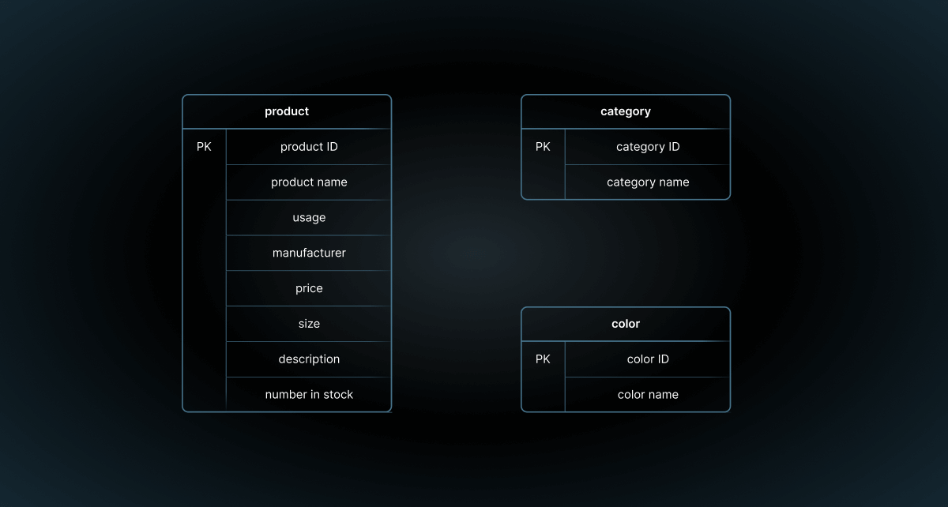

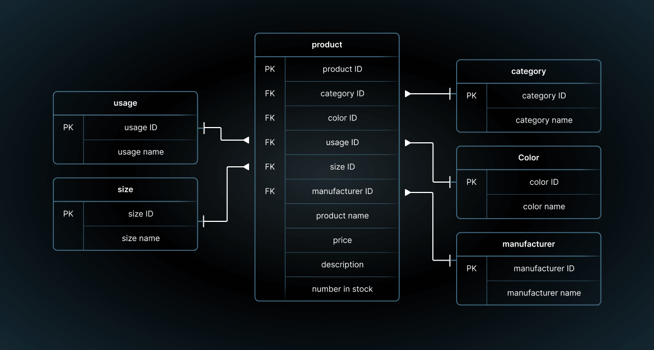

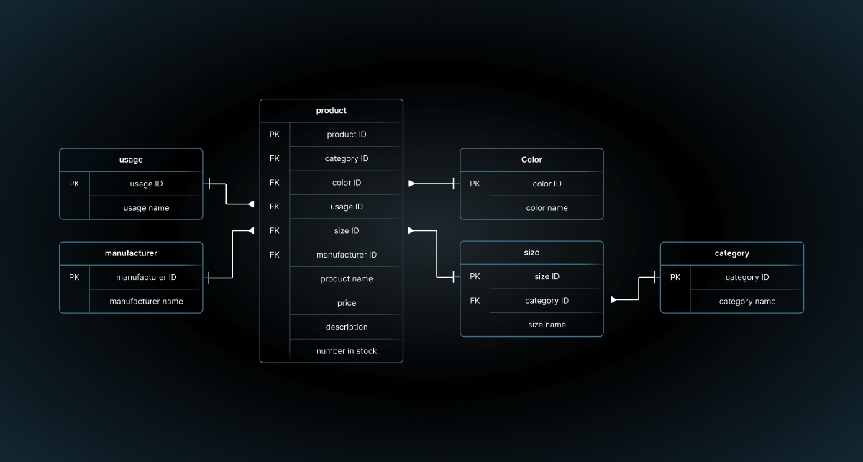

Nested Query (Subquery)
A query inside another query.
SELECT firstname, lastname
FROM employees
WHERE department_id = (SELECT department_id FROM departments WHERE department_name = 'Sales');

Day 3
Loops:
Loops in SQL can be used within stored procedures, functions, or triggers to perform repetitive tasks. In MySQL, you have several options for implementing loops: WHILE, REPEAT, and LOOP. Each of these has its own use cases and syntax.

1. WHILE Loop
The WHILE loop repeats a block of statements as long as a specified condition is true.
Syntax:
WHILE condition DO
-- statements
END WHILE;
Example:

DELIMITER $$

-- WHILE loop function

CREATE FUNCTION WHILE_Factorial(n INT)

RETURNS BIGINT

DETERMINISTIC

BEGIN

DECLARE result BIGINT DEFAULT 1;

DECLARE counter INT DEFAULT 1;

WHILE counter <= n DO

SET result = result * counter;

SET counter = counter + 1;

END WHILE;

RETURN result;

END$$
DELIMITER;

2. REPEAT Loop
The REPEAT loop repeats a block of statements until a specified condition is true. The condition is checked after the execution of the loop body, ensuring that the loop body is executed at least once.
Syntax:
REPEAT
-- statements
UNTIL condition
END REPEAT;
Example:

DELIMITER $$
CREATE FUNCTION REPEAT_Factorial(n INT)
RETURNS BIGINT
DETERMINISTIC
BEGIN
DECLARE result BIGINT DEFAULT 1;
DECLARE counter INT DEFAULT 1;
REPEAT
SET result = result * counter;
SET counter = counter + 1;
UNTIL counter > n
END REPEAT;
RETURN result;
END$$

DELIMITER;

3. LOOP
The LOOP construct is a more general form of loop that continues indefinitely until a LEAVE statement is executed. It is typically used with a LEAVE statement to exit the loop based on some condition.
Syntax:
LOOP
-- statements
IF condition THEN
LEAVE label;
END IF;
END LOOP;
Example:
DELIMITER $$
-- LOOP with LEAVE function
CREATE FUNCTION LOOP_Factorial(n INT)
RETURNS BIGINT
DETERMINISTIC
BEGIN
DECLARE result BIGINT DEFAULT 1;
DECLARE counter INT DEFAULT 1;
loop_label: LOOP
SET result = result * counter;
SET counter = counter + 1;
IF counter > n THEN
LEAVE loop_label;
END IF;
END LOOP;
RETURN result;
END$$
DELIMITER;

Cursors
A cursor in SQL is a database object used to retrieve, manipulate, and navigate through a result set row by row. Cursors are useful when you need to perform operations on individual rows of a result set, rather than performing operations on the entire set at once.
DECLARE @EmployeeID INT, @EmployeeName NVARCHAR(50);
-- Declare the cursor
DECLARE employee_cursor CURSOR FOR
SELECT EmployeeID, Name
FROM Employees;
-- Open the cursor
OPEN employee_cursor;
-- Fetch the first row
FETCH NEXT FROM employee_cursor INTO @EmployeeID, @EmployeeName;
-- Loop through the rows
WHILE @@FETCH_STATUS = 0
BEGIN
-- Process each row
PRINT 'Employee ID: ' + CAST(@EmployeeID AS NVARCHAR) + ', Name: ' + @EmployeeName;
-- Fetch the next row
FETCH NEXT FROM employee_cursor INTO @EmployeeID, @EmployeeName;
END;
-- Close the cursor
CLOSE employee_cursor;
-- Deallocate the cursor
DEALLOCATE employee_cursor;

- Declare: Define the cursor and specify the query.
- Open: Open the cursor to establish the result set.
- Fetch: Retrieve rows one at a time.
- Close: Close the cursor when done.
- Deallocate: Release the cursor's resources.

User-Defined Functions: User-defined functions (UDFs) in SQL Server are a powerful feature that allows you to encapsulate reusable logic in a SQL script. They can be used to simplify complex queries and make your code more modular and easier to maintain. There are three types of user-defined functions in SQL Server:
Scalar Functions
Inline Table-Valued Functions
Multi-Statement Table-Valued Functions

1. Scalar Functions
A scalar function returns a single value. This can be any data type, such as an integer, string, or date.
Syntax:
CREATE FUNCTION function_name (@parameter1 datatype, @parameter2 datatype, ...)
RETURNS return_datatype
AS
BEGIN
DECLARE @result return_datatype;
SET @result = ...;
RETURN @result;
END;

CREATE FUNCTION dbo.GetFullName (@FirstName NVARCHAR(50), @LastName NVARCHAR(50))
RETURNS NVARCHAR(101)
AS
BEGIN
RETURN @FirstName + ' ' + @LastName;
END;

2. Inline Table-Valued Functions
An inline table-valued function returns a table data type that can be used in a SELECT statement. This is similar to a view, but it can accept parameters.
Syntax:
CREATE FUNCTION function_name (@parameter1 datatype, @parameter2 datatype, ...)
RETURNS TABLE
AS
RETURN
(
SELECT ...
FROM ...
WHERE ...
);

CREATE FUNCTION dbo.GetEmployeesByDepartment (@DeptId INT)
RETURNS TABLE
AS
RETURN
(
SELECT EmployeeID, FirstName, LastName, DepartmentID
FROM Employees
WHERE DepartmentID = @DeptId
);

3. Multi-Statement Table-Valued Functions
A multi-statement table-valued function returns a table and allows for multiple SELECT statements and other logic to populate the table.

Syntax:
CREATE FUNCTION function_name (@parameter1 datatype, @parameter2 datatype, ...)
RETURNS @table_variable TABLE (column1 datatype, column2 datatype, ...)
AS
BEGIN
INSERT INTO @table_variable
SELECT ... FROM ... WHERE ...;
RETURN;
END;
CREATE FUNCTION dbo.GetEmployeeDetails (@DeptId INT)
RETURNS @EmployeeDetails TABLE
(
EmployeeID INT,
FullName NVARCHAR(101),
JobTitle NVARCHAR(50)
)
AS
BEGIN
INSERT INTO @EmployeeDetails
SELECT EmployeeID, FirstName + ' ' + LastName, JobTitle
FROM Employees
WHERE DepartmentID = @DeptId;

RETURN;
END;

MySQL supports two main types of UDFs:
- Scalar Functions
- Stored Functions

1. Scalar Functions
A scalar function in MySQL returns a single value. These are the most common type of user-defined function.
Syntax:
CREATE FUNCTION function_name (parameter1 datatype, parameter2 datatype, ...)
RETURNS return_datatype
BEGIN
DECLARE variable return_datatype;
SET variable = ...;
RETURN variable;
END;
Example:
DELIMITER $$
CREATE FUNCTION Factorial (n INT)
RETURNS BIGINT
DETERMINISTIC
BEGIN
DECLARE result BIGINT DEFAULT 1;
DECLARE i INT DEFAULT 1;
WHILE i <= n DO
SET result = result * i;
SET i = i + 1;
END WHILE;
RETURN result;
END$$
DELIMITER;

Explanation in Steps
- Changing the Delimiter:
  - The default statement delimiter in MySQL is a semicolon (;). Since the function definition contains multiple statements separated by semicolons, we temporarily change the delimiter to $$ to avoid confusion.
  - This changes the statement delimiter from ; to $$. This is necessary because the function body contains multiple statements, and we need to treat the whole function as a single statement.
- Function Declaration:
  - We create a function named CircleArea that takes a DOUBLE input parameter radius.
- Return Type and Determinism:
  - We specify that the function returns a DOUBLE and declare it DETERMINISTIC, meaning it consistently produces the same result given the same inputs.
- Function Body:
  - The function body is enclosed in BEGIN and END statements.
- Variable Declaration:
  - Inside the function, we declare a local variable area to hold the calculation result.
- Calculating the Area:
  - We use the formula for the area of a circle π×radius2\pi \times \text{radius}^2π×radius2 and assign the result to the area variable.
- Returning the Result:
  - The function returns the calculated area.
- Restoring the Delimiter:
  - Finally, we reset the delimiter back to the default semicolon (;).

Triggers:
Triggers in SQL Server are powerful tools that automatically execute specific actions when certain events occur on a database table.

Types of Triggers
- AFTER Trigger: Executes after the triggering event (INSERT, UPDATE, DELETE) has occurred.
- BEFORE Trigger: Executes before the triggering event takes place.
- INSTEAD OF Trigger: Overrides the default action of a SQL statement (INSERT, UPDATE, DELETE).
CREATE TABLE Employees (
EmployeeID INT PRIMARY KEY,
FirstName VARCHAR(50) NOT NULL,
LastName VARCHAR(50) NOT NULL,
DepartmentID INT NOT NULL,
Salary DECIMAL(18, 2) NOT NULL,
Role VARCHAR(50) NOT NULL
);
CREATE TABLE AuditLog (
AuditID INT IDENTITY(1,1) PRIMARY KEY,
Action VARCHAR(50) NOT NULL,
Timestamp DATETIME NOT NULL,
Details VARCHAR(255) NOT NULL
);

CREATE TABLE [dbo].[auditlog](
[AuditLogId] [int] IDENTITY(1,1) NOT NULL,
[Pk] [int] not NULL,
[Action] [varchar](10) NOT NULL,
[NewVal] [varchar](100) NULL,
[OldVal] [varchar](100) NULL,
[Timestamp] datetime NOT NULL,
)

After Event Triggers:
AFTER INSERT
CREATE TRIGGER trg_AfterInsertEmployee
ON dbo.Employees
AFTER INSERT
AS
BEGIN
INSERT INTO dbo.AuditLog (Action, Timestamp, Details)
SELECT 'INSERT', GETDATE(), CONCAT('New employee added: ', inserted.FirstName, ' ', inserted.LastName)
FROM inserted;
END;
AFTER UPDATE
CREATE TRIGGER trg_AfterUpdateEmployee
ON dbo.Employees
AFTER UPDATE
AS
BEGIN
INSERT INTO AuditLog (Action, Timestamp, Details)
SELECT 'UPDATE', GETDATE(), CONCAT('Updated EmployeeID: ', inserted.EmployeeID, ', New Salary: ', inserted.Salary)
FROM inserted;
END;

AFTER DELETE
CREATE TRIGGER trg_AfterDeleteEmployee
ON dbo.Employees
AFTER DELETE
AS
BEGIN
INSERT INTO AuditLog (Action, Timestamp, Details)
SELECT 'DELETE', GETDATE(), CONCAT('Employee deleted: ', deleted.EmployeeID)
FROM deleted;
END;

INSTEAD OF INSERT
CREATE TRIGGER trg_InsteadOfInsertEmployee
ON dbo.Employees
INSTEAD OF INSERT
AS
BEGIN
IF EXISTS (SELECT * FROM inserted WHERE Salary < 30000)
BEGIN
RAISERROR ('Salary must be at least $30,000', 16, 1);
ROLLBACK TRANSACTION;
END
ELSE
BEGIN
INSERT INTO Employees (EmployeeID, FirstName, LastName, DepartmentID, Salary, Role)
SELECT EmployeeID, FirstName, LastName, DepartmentID, Salary, Role
FROM inserted;
END
END;

INSTEAD OF UPDATE
CREATE TRIGGER trg_InsteadOfUpdateEmployee
ON dbo.Employees
INSTEAD OF UPDATE
AS
BEGIN
IF EXISTS (SELECT * FROM inserted INNER JOIN deleted ON inserted.EmployeeID = deleted.EmployeeID WHERE inserted.Salary < deleted.Salary AND deleted.Role = 'Manager')
BEGIN
RAISERROR ('Cannot reduce salary for managers', 16, 1);
ROLLBACK TRANSACTION;
END
ELSE
BEGIN
UPDATE Employees
SET FirstName = inserted.FirstName, LastName = inserted.LastName, DepartmentID = inserted.DepartmentID, Salary = inserted.Salary, Role = inserted.Role
FROM inserted
WHERE Employees.EmployeeID = inserted.EmployeeID;
END
END;

INSTEAD OF DELETE
CREATE TRIGGER trg_InsteadOfDeleteEmployee
ON dbo.Employees
INSTEAD OF DELETE
AS
BEGIN
IF EXISTS (SELECT * FROM deleted WHERE Role = 'Manager')
BEGIN
RAISERROR ('Cannot delete managers', 16, 1);
ROLLBACK TRANSACTION;
END
ELSE
BEGIN
DELETE FROM Employees
WHERE EmployeeID IN (SELECT EmployeeID FROM deleted);
END
END;

Day 4
Stored Procedure:
A stored procedure in SQL is a precompiled set of one or more SQL statements that can be executed as a unit. They allow you to encapsulate logic, make your SQL code modular, and improve performance by reducing the overhead of multiple query executions.
CREATE PROCEDURE GetAllEmployees
AS
BEGIN
SELECT * FROM Employees;
END;
Stored procedures can accept parameters, allowing you to pass data to them at execution time.
CREATE PROCEDURE GetEmployeeByID
@EmployeeID INT
AS
BEGIN
SELECT * FROM Employees WHERE EmployeeID = @EmployeeID;
END;
To execute the stored procedures created above:
-- Executing GetAllEmployees
EXEC GetAllEmployees;

-- Executing GetEmployeeByID with a parameter
EXEC GetEmployeeByID @EmployeeID = 1;

Practice example for modify Stored procedure
alter PROCEDURE GetCustomerTypes(@id int)
As
BEGIN
set nocount on;
Declare @SQLQuery nvarchar(max)
create table #mytemptable (id int, name varchar(100))
set @SQLQuery = 'insert into #mytemptable select * from CustomerTypes where CustomerTypeID =' + cast(@id as varchar)
print @SQLQuery
exec (@SQLQuery)
select * from CustomerTypes
select * from #mytemptable
END
GO

Views:
A view in SQL is a virtual table that is based on the result set of a SELECT query. Views can simplify complex queries, enhance security by restricting access to specific data, and provide a level of abstraction to isolate application developers from changes in the underlying database schema.
Creating a View
CREATE VIEW EmployeeDetails AS
SELECT EmployeeID, Name, Department, Salary
FROM Employees;

Practical Exercises
Create a database named 'company'
Create the following tables
1. departments
2. employees
Insert the data into the departments table and employee’s table

Queries
Retrieve all employee records from the employees table.
Select the firstname, lastname, and salary of employees who work in the 'Sales' department.
Find the average salary of employees in each department.
List the departments that have more than one employee.
Update the salary of 'John Doe' to 52000.
Delete the employee record of 'Jake White'.
Retrieve a list of all employees and their corresponding department names using a join.
Find the department with the highest average salary.
Add a new column email to the employees table.
Remove all employees who have a salary less than 50000 from the employees table

Assignment 1
1. Create a Database (Company)
2. Create an Employees table
3. Create a Departments table
4. Insert at least 5 records into the Departments table.
5. Insert at least 10 records into the Employees table.
6. Write query to retrieve Employees with Salary greater than 65000
7. Write query to Retrieve Employees hired after 2015
8. Find the average salary of Employees in each Department
9. Find the Department with the highest number of Employees
10. Retrieve Employees along with their Department names
11. Retrieve all Departments and their Employees (including Departments with no Employees)
13. Find Employees who earn more than the average salary using subquery
14. Add a constraint to the Employees table to ensure DepartmentID must exist in Departments table
15. Create a view that lists Employee names and their Department names
16. Start a transaction, insert a record into the Employees table, and then commit the transaction.
17. Start a transaction, insert a record into the Employees table, and then rollback the transaction
18. Retrieve the second highest salary from the Employees table
19. Retrieve Employees who have the same salary as someone in another Department
20. Retrieve the latest hire date for each Department
21. Retrieve Employees whose salary is above the average salary of their own Department
22. Create a Scalar Function to calculate annual salary
23. Create a Stored Procedure to retrieve Employees by Department
24. Create a trigger to log any INSERT operation on the Employees table
25. Retrieve Employees and their Managers (assume ManagerID is a column in Employees referencing EmployeeID)
26. Find Departments without any Employees using set operations
27. Create a WHILE loop in SQL Server to print numbers from 1 to 10
28. Create a REPEAT loop in MySQL to print numbers from 1 to 10
29. Create a LOOP in MySQL with a LEAVE statement
30. Create a Cursor in SQL Server to iterate over Employees table

